***Insert at Begin of Singly Linked List***

**Add a node at the front: (4 steps process)**

**Approach:** The new node is always added before the head of the given Linked List. And newly added node becomes the new head of the Linked List. For example, if the given Linked List is 10->15->20->25 and we add an item 5 at the front, then the Linked List becomes 5->10->15->20->25. Let us call the function that adds at the front of the list is push(). The push() must receive a pointer to the head pointer because the push must change the head pointer to point to the new node 

[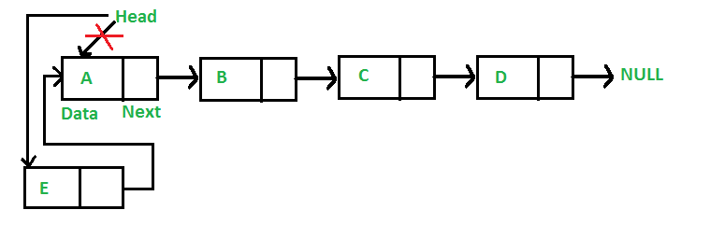](https://media.geeksforgeeks.org/wp-content/cdn-uploads/gq/2013/03/Linkedlist_insert_at_start.png)

Following are the 4 steps to add a node at the front.

C++Java

/* This function is in LinkedList class. Inserts a

new Node at front of the list. This method is

defined inside LinkedList class shown above */

public void push(int new_data)

{

/* 1 & 2: Allocate the Node &

Put in the data*/

Node new_node = new Node(new_data);

/* 3. Make next of new Node as head */

new_node.next = head;

/* 4. Move the head to point to new Node */

head = new_node;

}

**Complexity Analysis:**

* **Time Complexity:** O(1), We have a pointer to the head and we can directly attach a node and change the pointer. So the Time complexity of inserting a node at the head position is O(1) as it does a constant amount of work.
* **Auxiliary Space:**O(1)